**Name :- Mayuri Chatke**

**Assignment:- 1**

Question 1

What will the code below output to the console and why ?

console.log(1 + "2" + "2");

**Answer**: **It gives 122 Because if at least one string in list add number in string gives the concatenation of the list.**

console.log(1 + +"2" + "2");

**Answer:- IT gives 32 Because ++ operator increment the string .**

console.log(1 + -"1" + "2");

**Answer:- It gives the 2 +- is minus so 1+- 1 is 0.**

console.log(+"1" + "1" + "2");

**Answer:- It gives 112 all elements are strings so it concatenate.**

console.log( "A" - "B" + "2");

**Answer:- NAN**

console.log( "A" - "B" + 2);

Answer:- **NAN**

**Output of the above code:-**

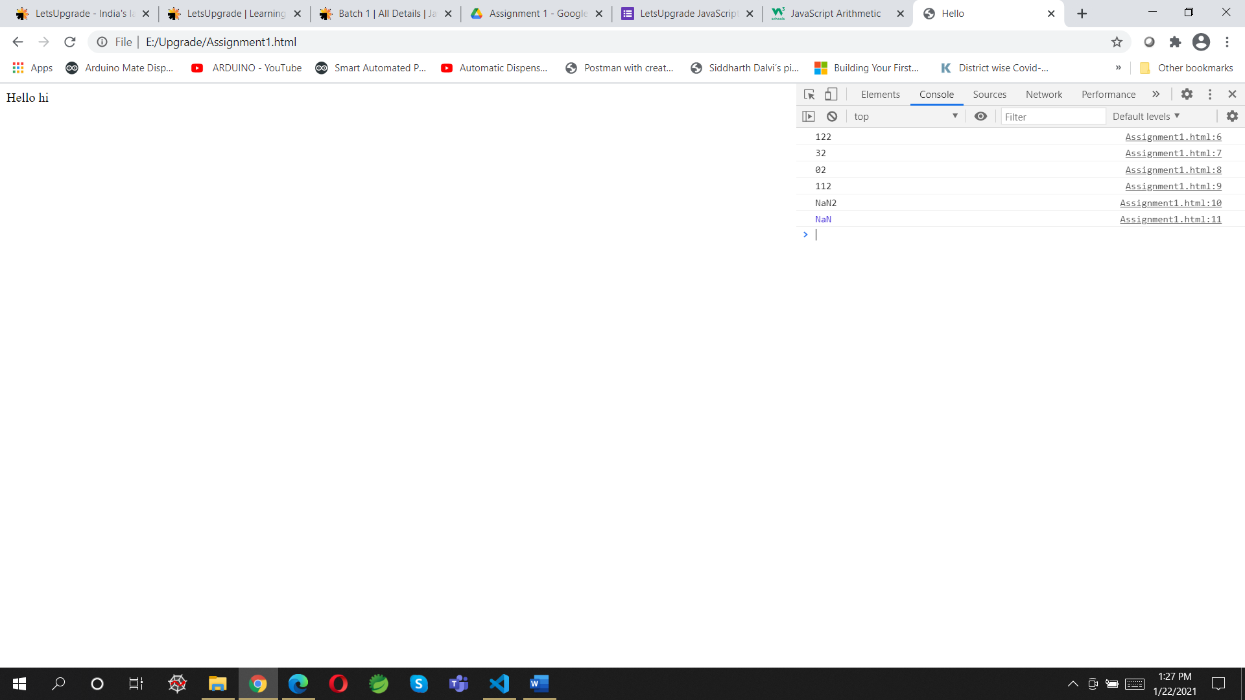

Question 2

You are given a variable “marks”. Your task is to print

- AA if the mark is greater than 90

- AB if the mark is greater than 80 and less than or equal to 90

- BB if the mark is greater than 70and less than or equal to 80

- BC if the mark is greater than 60 and less than or equal to 70

- CC if the mark is greater than 50 and less than or equal to 60

- CD if the mark is greater than 40 and less than or equal to 50

- DD if the mark is greater than 30 and less than or equal to 40

- FF if the mark is less than or equal to 30

Answer:-  <script>

        var marks = window.prompt("Enter the Marks");

       // alert("your marks is" +marks);

        if(marks>90){

            console.log("AA");

        }

        else

        if(marks>80 && marks<=90){

            console.log("AB");

        }else if(marks>70 && marks<=80){

            console.log("BB");

        }else if(marks>60 && marks<=70){

            console.log("BC")

        }else if(marks>50 && marks<=60){

            console.log("CC")

        }else if(marks>40 && marks<=50){

            console.log("CD");

        }else if(marks>30 && marks<=40){

            console.log("DD");

        }

        else

            {

                console.log("FF");

            }

 </script>

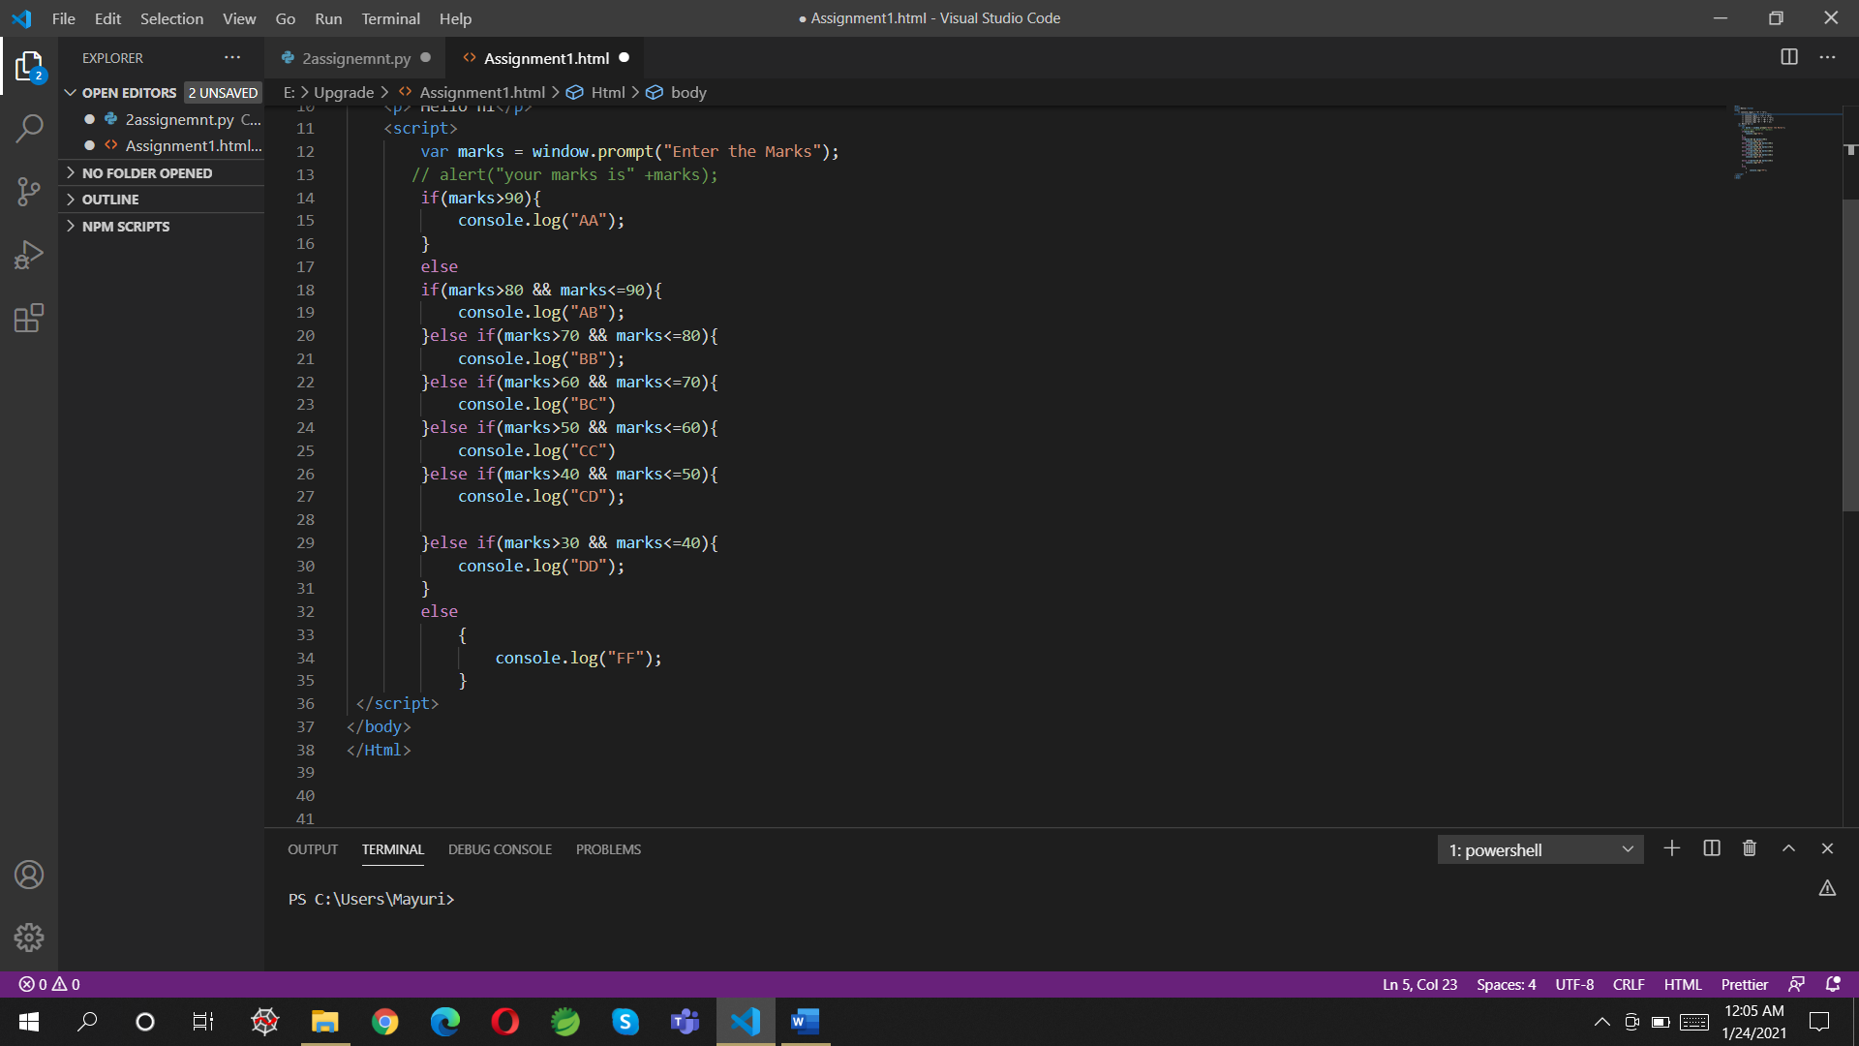

Output:-

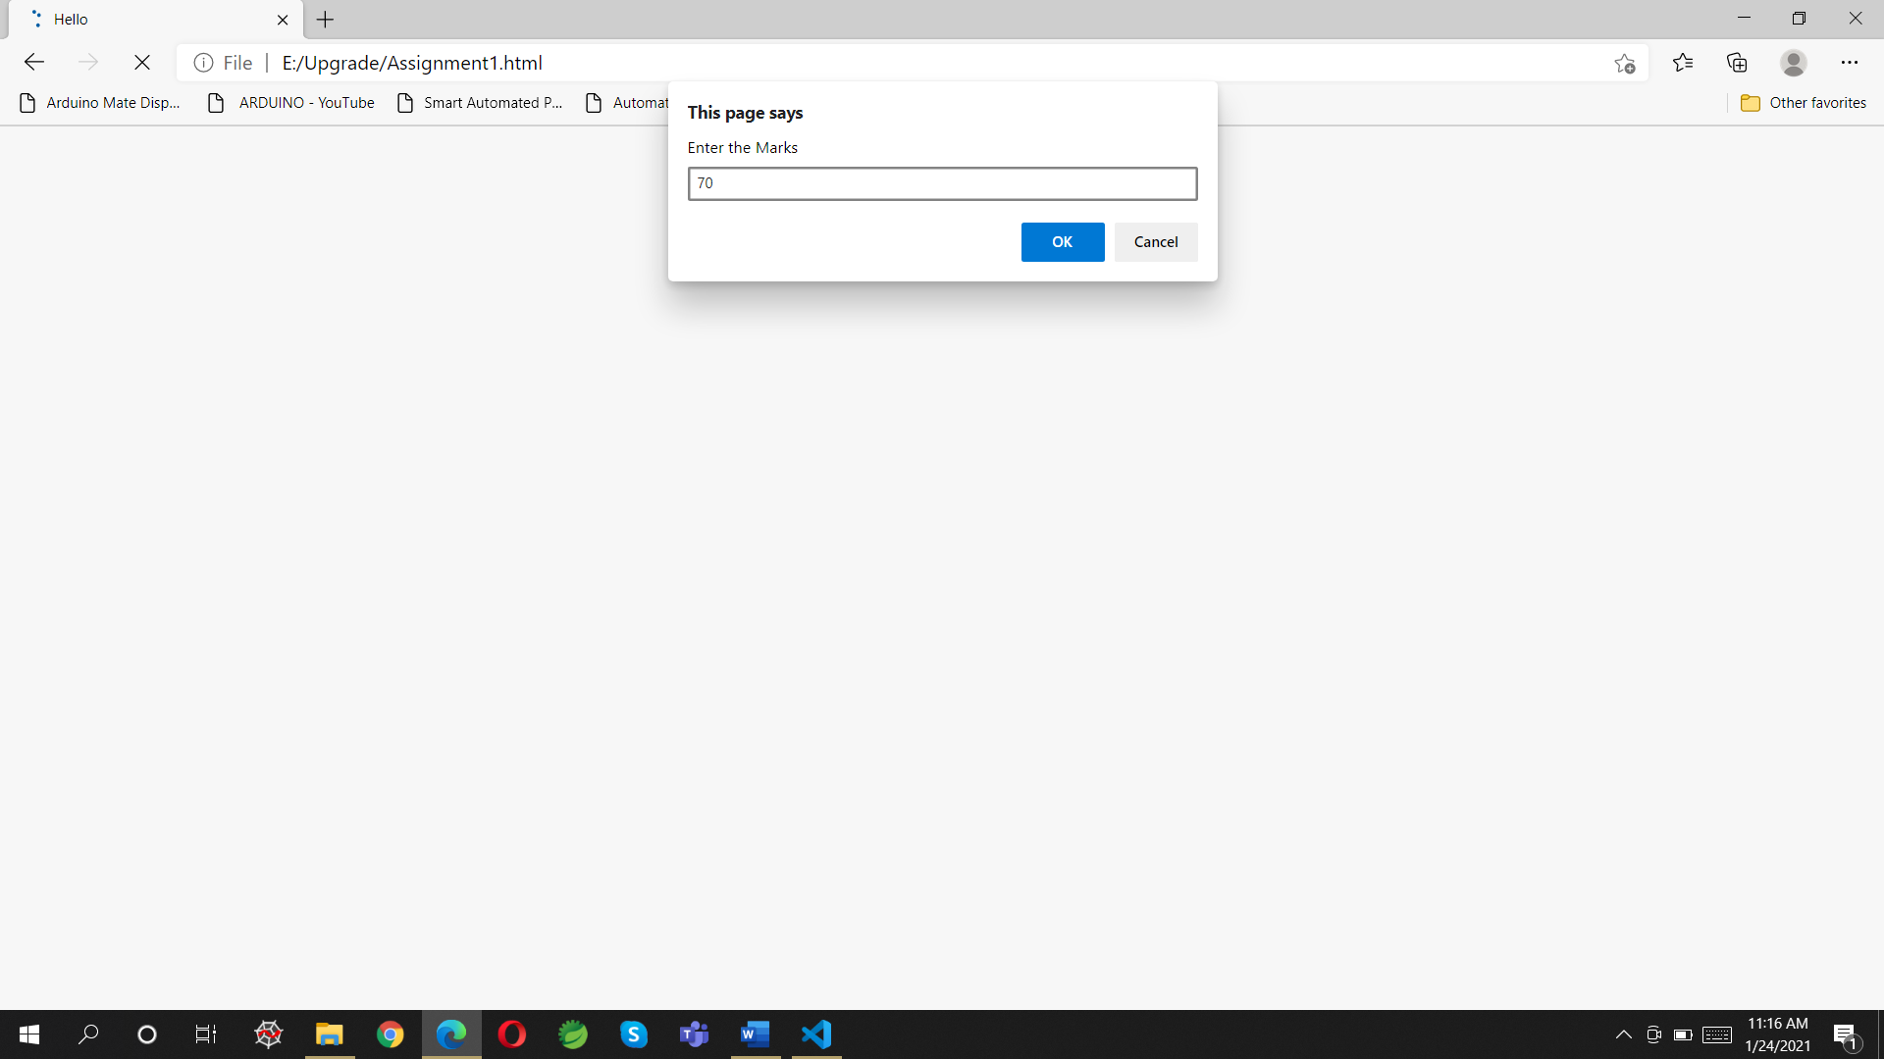

When we enter the 70 it as give BC as per condition

